Oakwood Homes – Ebert’s Terrace
Denver, CO

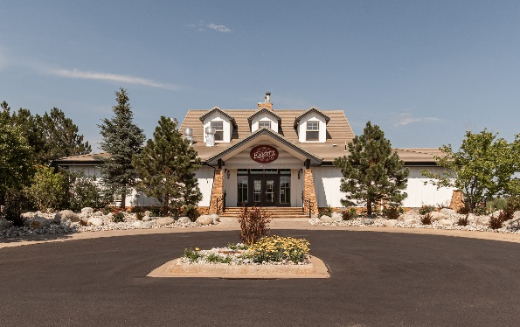
Project Details
Description: 5,800 sf Restaurant/Bar Remodel
Owner: Oakwood Homes
Architect: LAI Design Group
General Contractor: Spartan Construction
Budget: $2.95M
Completion: May 2019

Project Description
Ebert’s Terrace is a 5,800 sf restaurant & bar located on the Green Valley Ranch Golf Course in Denver, CO. The restaurant and bar features a 1,150 sf multi-use room for Oakwood Life members that includes a private 550 sf deck. The project scope included the addition of a new kitchen and bar with overhead rolling doors to open the space to the exterior. Additionally, the project expanded the existing deck to over 1,850 sf of outdoor dining space.
Scope of Services
Chris Landry served as Project Executive for the duration of the design and construction of the Restaurant, overseeing and managing virtually all aspects of the project over a 9-month period. Responsibilities included, but not limited to:
- Ongoing development and management of the complete project budget, including monthly management, tracking and reporting to the client of all change orders, contingency usage, budget transfers and commitment levels
- Close coordination with the GVR Golf Course to minimize disruption to golf operations, including an underground bore for a fiber line to connect the restaurant and golf clubhouse
- Close supervision of the project schedule, with strong control over critical design, preconstruction, construction, utility, FF&E and building systems commissioning milestones
- Oversight of the architectural design team and close tracking of their progress towards achieving the Restaurants programmatic and aesthetic/architectural goals, as well as construction cost targets
- Management of the kitchen equipment consultant for the design and installation of kitchen equipment
- Monthly construction draw reviews and daily monitoring and negotiation of potential and realized construction change orders
- Preparation of monthly reports for the Owner
- Negotiation, engagement and management of contracts with secondary consultants in the fields of geotechnical, survey, network and security design, audio/visual and signage design
- Furniture Fixtures and Equipment (FF&E) selection and procurement, including restaurant and bar specific furniture and equipment through several distinct vendors and specialty fabricators
- Coordination of close-out activities with all vendors and consultants

Oakwood Homes – Ebert’s Terrace
Denver, CO

